Title

Mahgoub Elhaj＊, Malik Mohammed Ali Alneel§

*Civil Engineering Department, Engineering College, Karary University, Sudan

§Chemical Engineering Department, Sudan University of Science and Technology, Sudan

**E-mail**: mahgoub@gmail.com

**Abstrac**t The 1st Scientific Conference for Aerospace Researches & Applications (SCARA-1) provides an effective aid for the dissemination of Engineering and science researches, inspiring interdisciplinary research cooperation to solve the problems related to the engineering and aerospace materials. The 1st Scientific Conference for Aerospace Researches & Applications (SCARA-1) provides an effective aid for the dissemination of Engineering and science researches, inspiring interdisciplinary research cooperation to solve the problems related to the engineering and aerospace materials. The 1st Scientific Conference for Aerospace Researches & Applications (SCARA-1) provides an effective aid for the dissemination of Engineering and science researches, inspiring interdisciplinary research cooperation to solve the problems related to the engineering and aerospace materials.

**Keywords** : keyword1; keyword2 ; keyword2

1. Section

SCARA-1 provides an effective aid for the dissemination of Engineering and science researches, inspiring interdisciplinary research cooperation to solve the problems related to the engineering and science fields. SCARA-1 provides an effective aid for the dissemination of Engineering and science researches, inspiring interdisciplinary research cooperation to solve the problems related to the engineering and science fields. SCARA-1 provides an effective aid for the dissemination of Engineering and science researches, inspiring interdisciplinary research cooperation to solve the problems related to the engineering and science fields. SCARA-1 provides an effective aid for the dissemination of Engineering and science researches, inspiring interdisciplinary research cooperation to solve the problems related to the engineering and science fields. SCARA-1 provides an effective aid for the dissemination of Engineering and science researches, inspiring interdisciplinary research cooperation to solve the problems related to the engineering and science fields.



Fig.1. Configuration model of SVC.

 (1)

SCARA-1 provides an effective aid for the dissemination of Engineering and science researches, inspiring interdisciplinary research cooperation to solve the problems related to the engineering and science fields. SCARA-1 provides an effective aid for the dissemination of Engineering and science researches, inspiring interdisciplinary research cooperation to solve the problems related to the engineering and science fields. SCARA-1 provides an effective aid for the dissemination of Engineering and science researches, inspiring interdisciplinary research cooperation to solve the problems related to the engineering and science fields. SCARA-1 provides an effective aid for the dissemination of Engineering and science researches, inspiring interdisciplinary research cooperation to solve the problems related to the engineering and science fields.

2. Section

2.1 Subsection SCARA-1 provides an effective aid for the dissemination of Engineering and science researches, inspiring interdisciplinary research cooperation to solve the problems related to the engineering and science fields. SCARA-1 provides an effective aid for the dissemination of Engineering and science researches, inspiring inter disciplinary research cooperation to solve the problems related to the engineering and science fields. SCARA-1 provides an effective aid for the dissemination of Engineering and science researches, inspiring interdisciplinary research cooperation to solve the problems related to the engineering and science fields

2.2 Subsection SCARA-1 provides an effective aid for the dissemination of Engineering and science researches, inspiring interdisciplinary research cooperation to solve the problems related to the engineering and science fields.

SCARA-1 provides an effective aid for the dissemination of Engineering and science researches, inspiring interdisciplinary research cooperation to solve the problems related to the engineering and science fields.

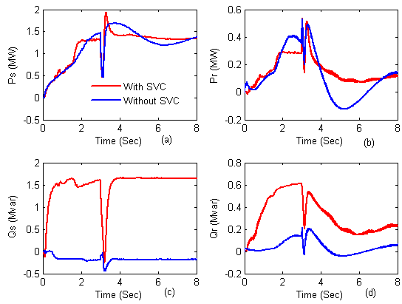

Fig.2. DFIG stator and rotor powers: (a) stator power; (b) rotor power; (c) stator reactive power; (d) rotor reactive power

.

SIJES provides an effective aid for the dissemination of Engineering and science researches, inspiring interdisciplinary research cooperation to solve the problems related to the engineering and science fields. SCARA-1 provides an effective aid for the dissemination of Engineering and science researches, inspiring interdisciplinary research cooperation to solve the problems related to the engineering and science fields [1].

SCARA-1 provides an effective aid for the dissemination of Engineering and science researches, inspiring interdisciplinary research cooperation to solve the problems related to the engineering and science fields. SCARA-1 provides an effective aid for the dissemination of Engineering and science researches, inspiring interdisciplinary research cooperation to solve the problems related to the engineering and science fields [2-4]. SCARA-1 provides an effective aid for the dissemination of Engineering and science researches, inspiring interdisciplinary research cooperation to solve the problems related to the engineering and science fields. SCARA-1 provides an effective aid for the dissemination of Engineering and science researches, inspiring interdisciplinary research cooperation to solve the problems related to the engineering and science fields. SCARA-1 provides an effective aid for the dissemination of Engineering and science researches, inspiring interdisciplinary research cooperation to solve the problems related to the engineering and science fields. SCARA-1 provides an effective aid for the dissemination of Engineering and science researches, inspiring interdisciplinary research cooperation to solve the problems related to the engineering and science fields. SCARA-1 provides an effective aid for the dissemination of Engineering and science researches, inspiring interdisciplinary research cooperation to solve the problems related to the engineering and science fields [5].

Table 1 table caption

|  |  |  |  |  |
| --- | --- | --- | --- | --- |
|  |  |  |  |  |
|  |  |  |  |  |

References

[1] Zakieldeen Elhassan, Tang Yi, and L. Yang. *Comparative study of voltage oriented and frequency coordinated control of grid connected doubly fed induction generator.* *Journal of Renewable and Sustainable Energy*, 2014. **6**(023120(2014)): 120.1-17.

[2] Zakieldeen Elhassan, Tang Yi, and L. Yang. *Proposed Control Method of Doubly Fed Induction Generator Rotor Side Converter Based on System Frequency Regulation.* *Applied Mechanics and Materials*, 2014. **548-549**: 806-814.

[3] Elhassan, Z., L. Yang, and T. Yi. *A Novel SSR Mitigation Method Based on GCSC in DFIG with Series Connected Compensator.* *TELKOMNIKA Indonesian Journal of Electrical Engineering*, 2014. **12**(7).

[4] Elhassan, Z., Y. Li, and Y. Tang. *Simplified voltage control of paralleling doubly fed induction generators connected to the network using SVC.* *International Transactions on Electrical Energy Systems*, 2015. **25**(11): 2847-2864.

[5] S.M. Muyeen, Junji Tamura, and T. Murata, *Stability Augmentation of a Grid-connected Wind Farm*. Green Energy and Technology. 2009, © 2009 Springer-Verlag London Limited: Springer.

**Mahgoub Elhaj** is an assistant professor of structural engineering inCivil Engineering Department, Faculty of Engineering,Karary University,Khartoum, Sudan. He received his B.Sc. and M.Sc. degrees in structural engineering from Karary University and his Ph.D. degree in Steel Structural from Northeast Forestry University, Harbin, China. His current research interests include design of concrete, steel and masonry structures, and computer aided analysis and design.

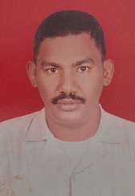 **Malik Mohammed Ali Alneel** is an assistant professor of structural engineering inCivil Engineering Department, Faculty of Engineering,Karary University,Khartoum, Sudan. He received his B.Sc., M.Sc. and Ph.D. degrees in structural engineering from Karary University. His current research interests include design of concrete, steel and masonry structures, and computer aided analysis and design.